**به نام خدا**

**پروژه درس مدیریت مصرف انرژی در ساختمان**

**استاد مربوطه درس: دکتر رجبی**

**دستیار محترم مربوطه درس: دکتر فلاح‌پور**

پروژه بنده تشکیل شده است از دو طبقه شامل طبقه زیرزمین و طبقه همکف می‌باشد که فایل‌های مورد نظر پیوست شده است شامل فرضیات مورد استفاده شده و فایل‌های مورد نظر سعی شده است نمای ساختمان تا حدی شبیه به واقعیت باشد .  
بنده پروژه را به تنهایی انجام دادم.

* تغییرات ایجاد شده در بخشactivity و مشخصاً بخش‌های activity template و metabolic و computers و همچنین office equipment می‌باشد.
* در نقشه اصلی در موارد که مربوط به بانوان می‌باشد، مثلا سرویس‌های بهداشتی، که در آنجا فاکتور 0.85 در نظر گرفته می‌شود.
* در نقشه اصلی در موارد که مربوط به آقایون می‌باشد، مثلا سرویس‌های بهداشتی، که در آنجا فاکتور 1 در نظر گرفته می‌شود.
* در نقشه اصلی در موارد که مربوط به بانوان می‌باشد، مثلا سرویس‌های بهداشتی، که در آنجا فاکتور 0.85 در نظر گرفته می‌شود.
* و در برخی موارد میانگین وزنی بانوان و آقایان و یا عدد پیش فرض 0.9 یا میانگین وزنی بانوان و آقایان، 0.925 را قرار دادیم.
* توان مورد استفاده در بخش computer و office equipment از فرض تقریبی تعداد دستگاه‌های موجود تقسیم بر مساحت مورد نظر مورد محاسبه قرار گرفته‌اند.

**طبقه زیرزمین:**

**نمای ساختمان و زون‌ها:**

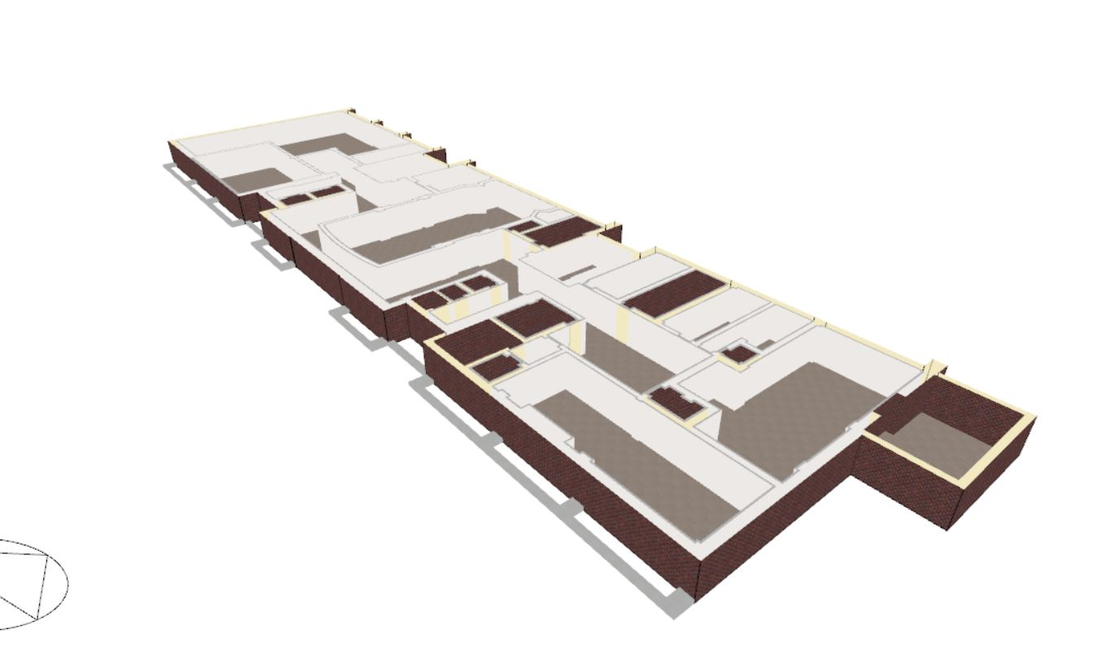

**طراحی گرمایشی:**

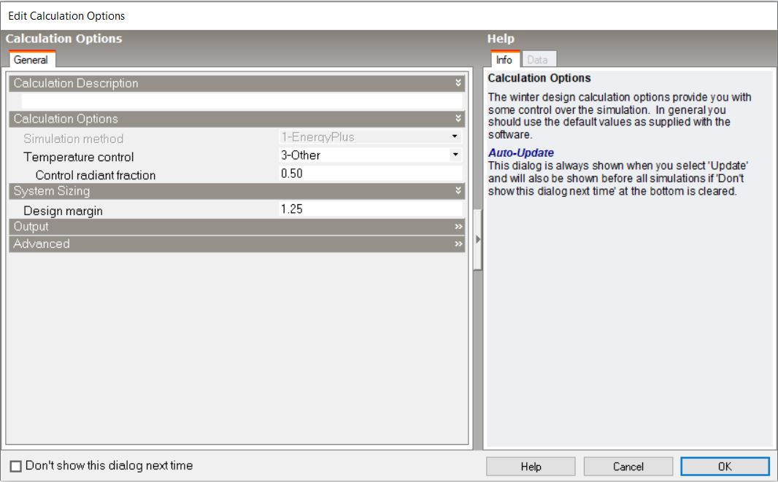

تحلیل داده‌های **heating design** به این صورت می‌باشد:

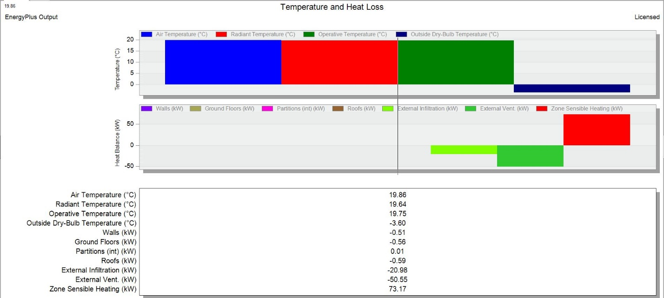

**خلاصه داده‌ها نیز به صورت زیر می‌باشد:**

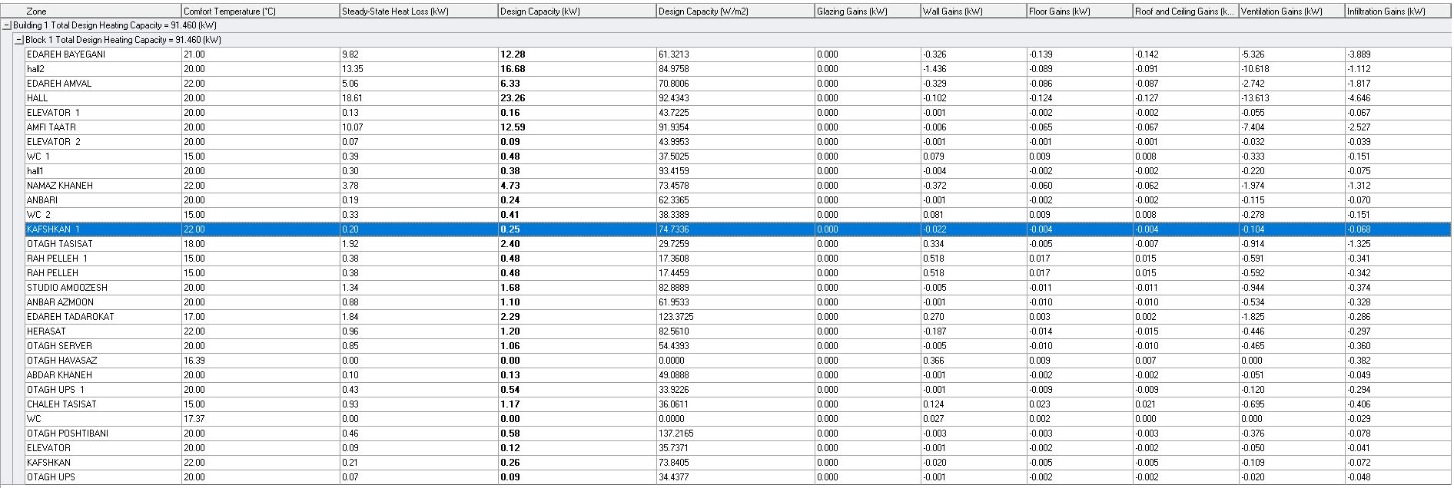

**طراحی سرمایشی:**

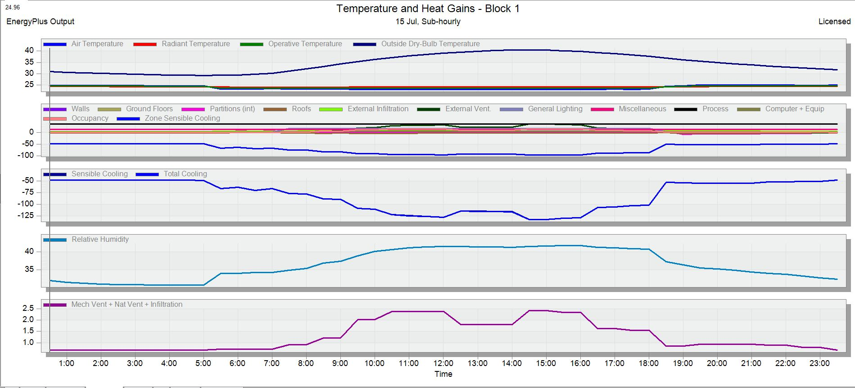

**بخشی خلاصه داده‌ها نیز به صورت زیر می‌باشد:**

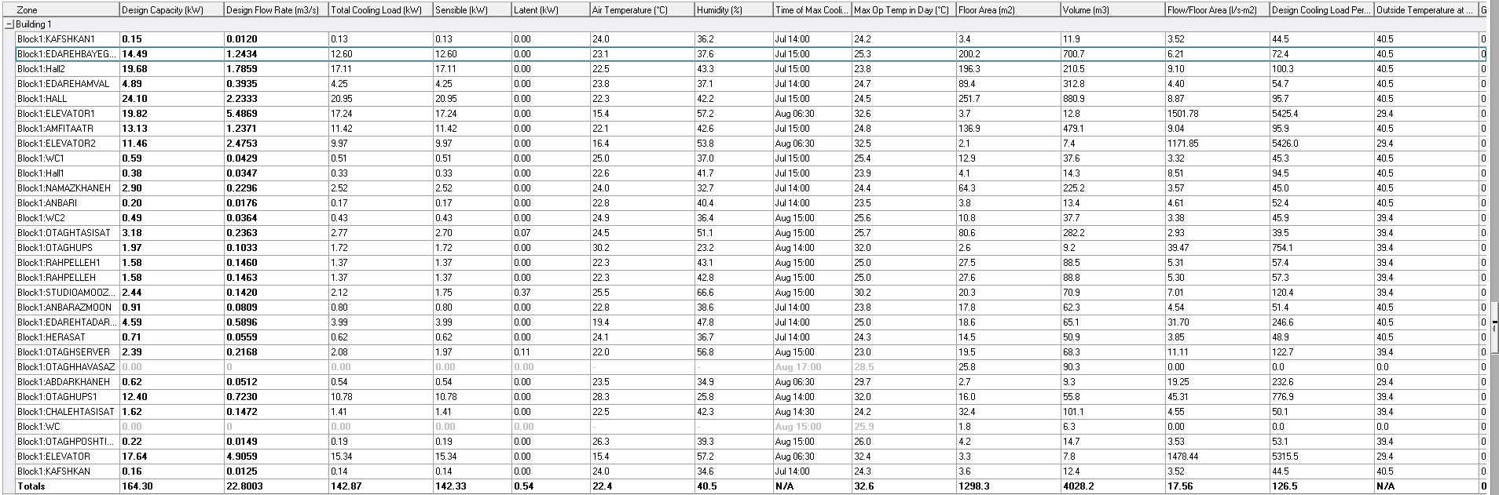

بخش شبیه سازی:

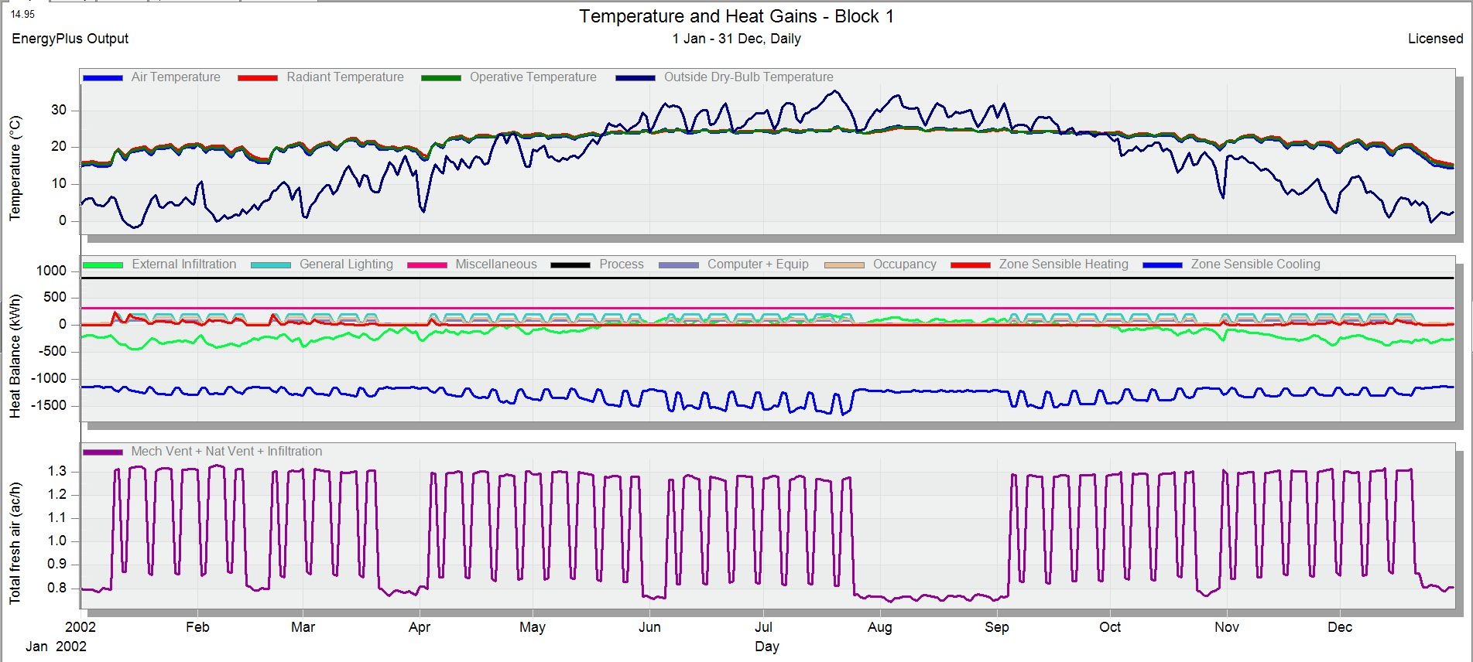

داده*‌های مورد استفاده در این طبقه نیز به شکل زیر می‌باشد:*ی‌هاسیبی سسیسیسشسشیی

|  |  |  |
| --- | --- | --- |
| **zone** | **zone type** | **sector** |
| **abdar khane** | semi-exterior unconditioned | general |
| **amfi theatre** | standard | education(non-residential institution) |
| **anbar azmoon** | semi-exterior unconditioned | education(non-residential institution) |
| **anbari** | semi-exterior unconditioned | education(non-residential institution) |
| **chaleh tasisat** | semi-exterior unconditioned | education(non-residential institution) |
| **adareh amval** | standard | residential institutions-residential schools |
| **edareh beyegani** | standard | education(non-residential institution) |
| **edareh tadarokat** | standard | education(non-residential institution) |
| **elevator** | semi-exterior unconditioned | general |
| **elevator1** | semi-exterior unconditioned | general |
| **elevator2** | semi-exterior unconditioned | general |
| **hall** | standard | education(non-residential institution) |
| **herasat** | standard | residential institutions-residential schools |
| **kafshkan** | semi-exterior unconditioned | residential institutions-residential schools |
| **kafshkan1** | semi-exterior unconditioned | residential institutions-residential schools |
| **namaz khaneh** | standard | residential institutions-residential schools |
| **otagh havasaz** | plenum | general industrial and special group |
| **otagh poshtibani** | standard | general |
| **otagh server** | srandard | others-miscellaneaous 24h activities |
| **otagh tasisat** | plenum | general industrial and special group |
| **otagh ups** | semi-exterior unconditioned | general |
| **otagh ups1** | semi-exterior unconditioned | general |
| **rah pelleh** | cavity | education(non-residential institution) |
| **rah pelleh 1** | cavity | education(non-residential institution) |
| **studio amoozesh** | standard | general |
| **wc** | semi-exterior unconditioned | education(non-residential institution) |
| **wc1** | semi-exterior unconditioned | education(non-residential institution) |
| **wc2** | semi-exterior unconditioned | education(non-residential institution) |
| **hall1** | standard | education(non-residential institution) |
| **hall2** | standard | education(non-residential institution) |

|  |  |  |
| --- | --- | --- |
| **zone** | **template** | **computers** |
| **abdar khane** | ashrey-kitchenette | no |
| **amfi theatre** | hall/lecture theatre/ assembly area/ | yes |
| **anbar azmoon** | store room | no |
| **anbari** | store room | no |
| **chaleh tasisat** | circulation area (corridors and stairwys) | no |
| **adareh amval** | residents common rooms | yes |
| **edareh beyegani** | office and consulting area | yes |
| **edareh tadarokat** | food prepration area | no |
| **elevator** | Misc.Spaces-electrical equipment room | no |
| **elevator1** | Misc.Spaces-electrical equipment room | no |
| **elevator2** | Misc.Spaces-electrical equipment room | no |
| **hall** | hall/lecture theatre/ assembly area/ | no |
| **herasat** | residents common rooms | no |
| **kafshkan** | residents common rooms | no |
| **kafshkan1** | residents common rooms | no |
| **namaz khaneh** | residents common rooms | no |
| **otagh havasaz** | indusrtial process area | no |
| **otagh poshtibani** | sports entertainment/studio | yes |
| **otagh server** | server room | yes |
| **otagh tasisat** | indusrtial process area | no |
| **otagh ups** | Misc.Spaces-electrical equipment room | yes |
| **otagh ups1** | Misc.Spaces-electrical equipment room | yes |
| **rah pelleh** | circulation area (corridors and stairwys) | no |
| **rah pelleh 1** | circulation area (corridors and stairwys) | no |
| **studio amoozesh** | educational facilities media center(library) | yes |
| **wc** | toilet | no |
| **wc1** | toilet | no |
| **wc2** | toilet | no |
| **hall1** | hall/lecture theatre/ assembly area/ | no |
| **hall2** | hall/lecture theatre/ assembly area/ | no |

|  |  |  |  |
| --- | --- | --- | --- |
| **zone** | **activity** | **factor** | **office equipment** |
| **abdar khane** | eating drinking | 0.925(both men and women) | no |
| **amfi theatre** | standing/walking | 0.9 | yes |
| **anbar azmoon** | light office work | 0.9 | no |
| **anbari** | standing/walking | 0.9 | no |
| **chaleh tasisat** | standing/walking | 0.9 | no |
| **adareh amval** | office work/standing/walking | 0.9 | yes |
| **edareh beyegani** | light office work/standing/walking | 0.9 | yes |
| **edareh tadarokat** | cooking 3 | 0.9 | yes |
| **elevator** | light | 0.86((1+0.85+0.75)/3) | no |
| **elevator1** | light | 0.86((1+0.85+0.75)/3) | no |
| **elevator2** | light | 0.86((1+0.85+0.75)/3) | no |
| **hall** | standing/walking | 0.9 | yes |
| **herasat** | office work/standing/walking | 0.9 | yes |
| **kafshkan** | seated quiet | 0.85 | no |
| **kafshkan1** | seated quiet | 1 | no |
| **namaz khaneh** | reclining | 0.925(both men and women) | no |
| **otagh havasaz** | heavy | 0.9 | no |
| **otagh poshtibani** | lecture | 0.925(both men and women) | no |
| **otagh server** | heavy | 0.9 | yes |
| **otagh tasisat** | heavy | 1 | no |
| **otagh ups** | light | 1 | yes |
| **otagh ups1** | light | 1 | yes |
| **rah pelleh** | standing/walking | 0.925 | no |
| **rah pelleh 1** | standing/walking | 0.925 | no |
| **studio amoozesh** | heavy | 1 | yes |
| **wc** | standing/walking | 0.925 | no |
| **wc1** | standing/walking | 1(men) | no |
| **wc2** | standing/walking | 0.85 | no |
| **hall1** | standing/walking | 0.9 | no |
| **hall2** | standing/walking | 0.9 | no |

**طبقه اول:**

**نمای ساختمان و زون‌ها:**

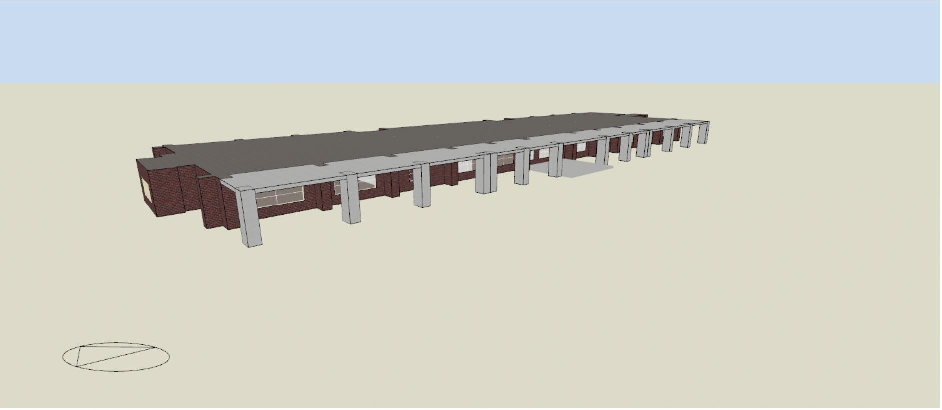

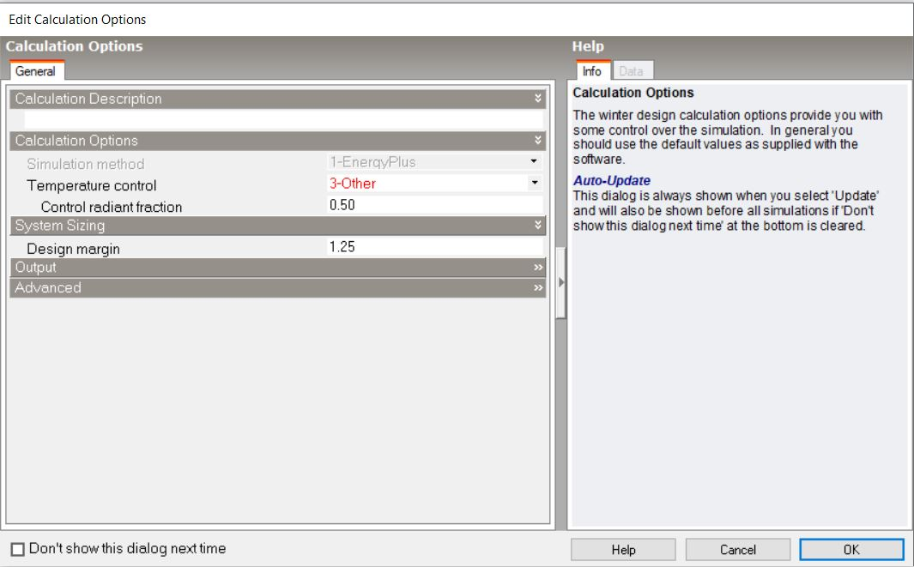**طراحی گرمایشی:**

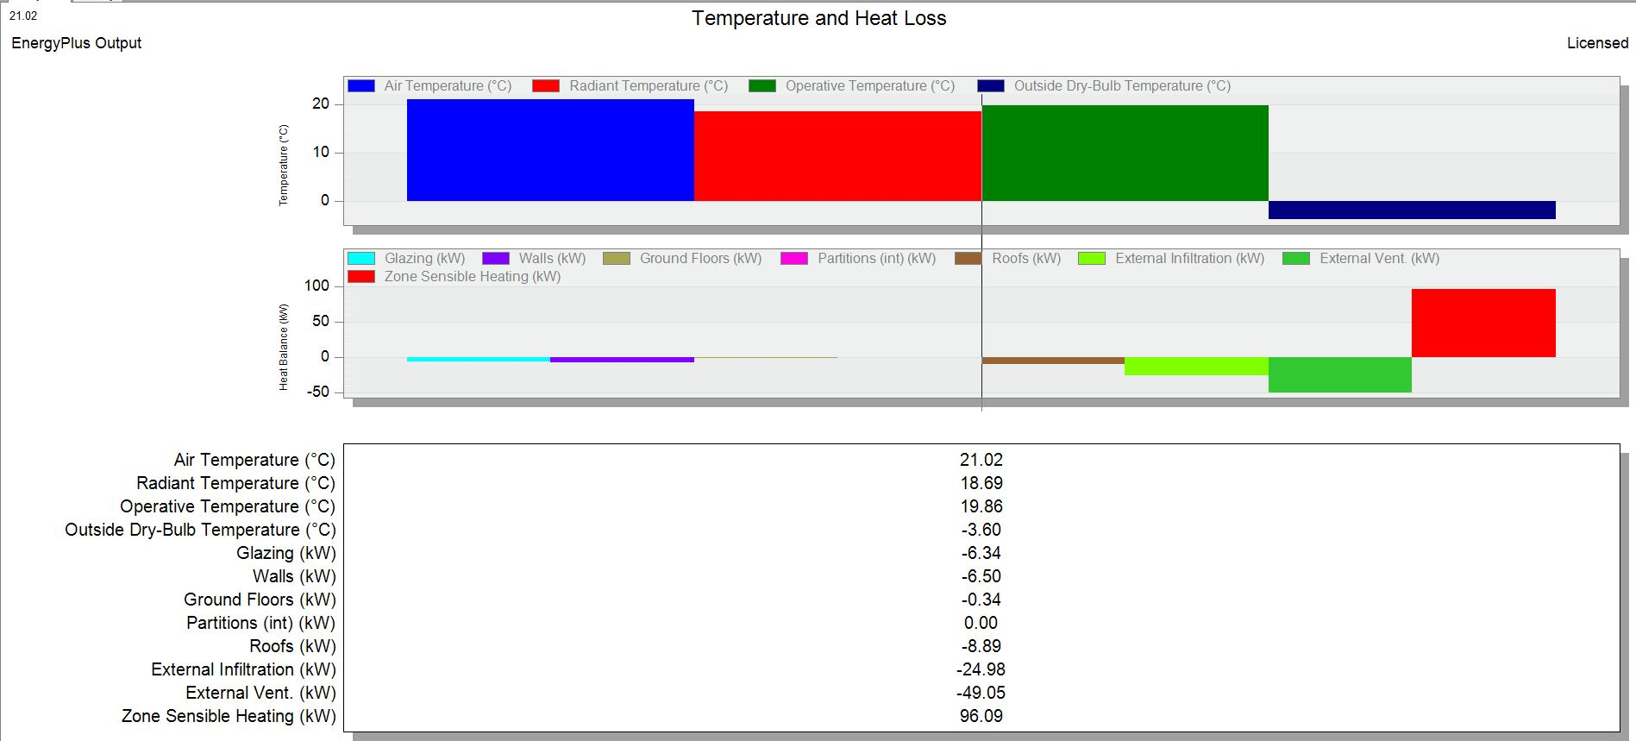تحلیل داده‌های **heating design** به این صورت می‌باشد:

**بخشی خلاصه داده‌ها نیز به صورت زیر می‌باشد:**

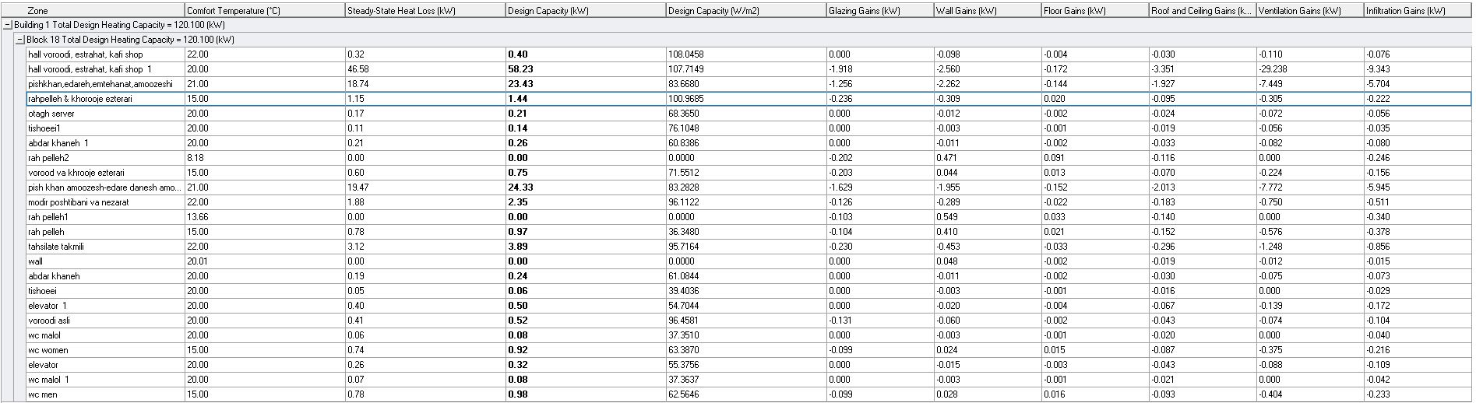

**طراحی سرمایشی:**

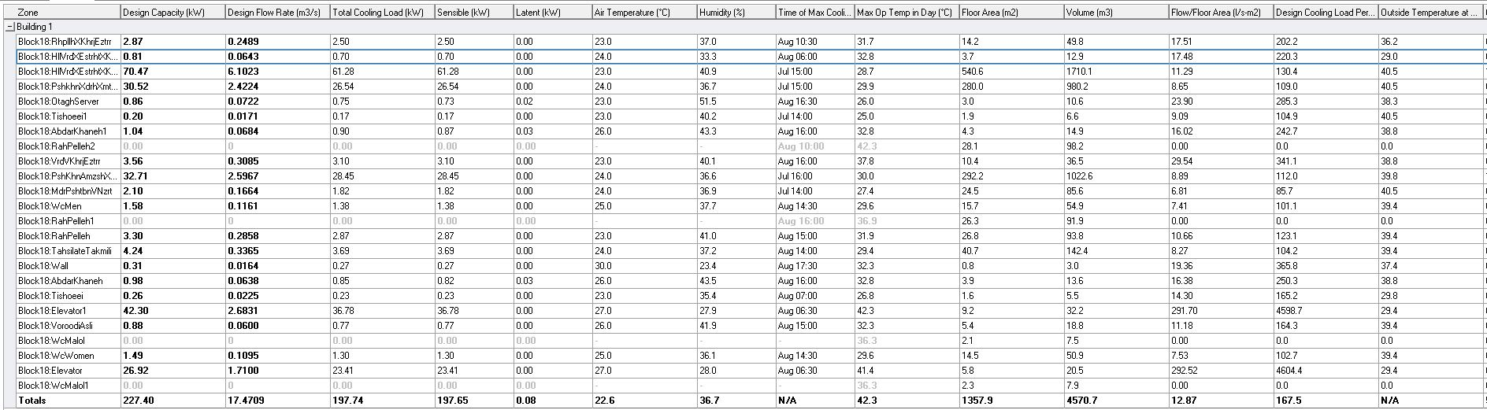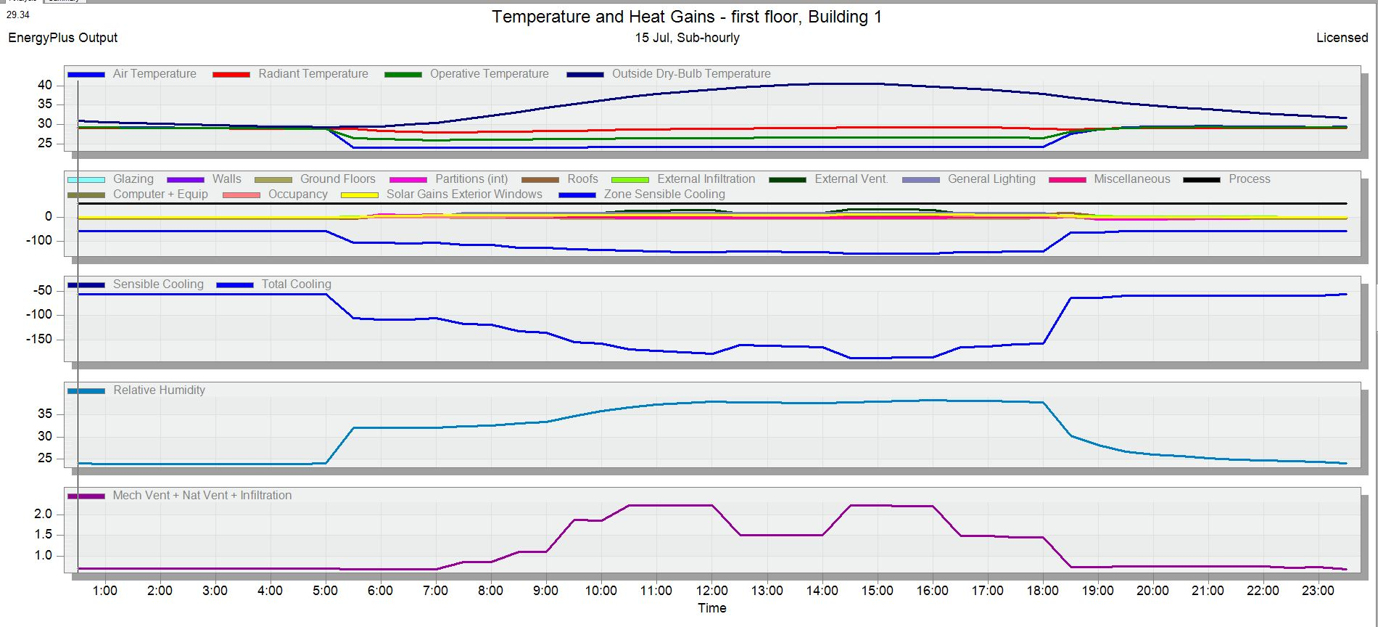

**بخشی خلاصه داده‌ها نیز به صورت زیر می‌باشد:**

شبیه‌سازی:

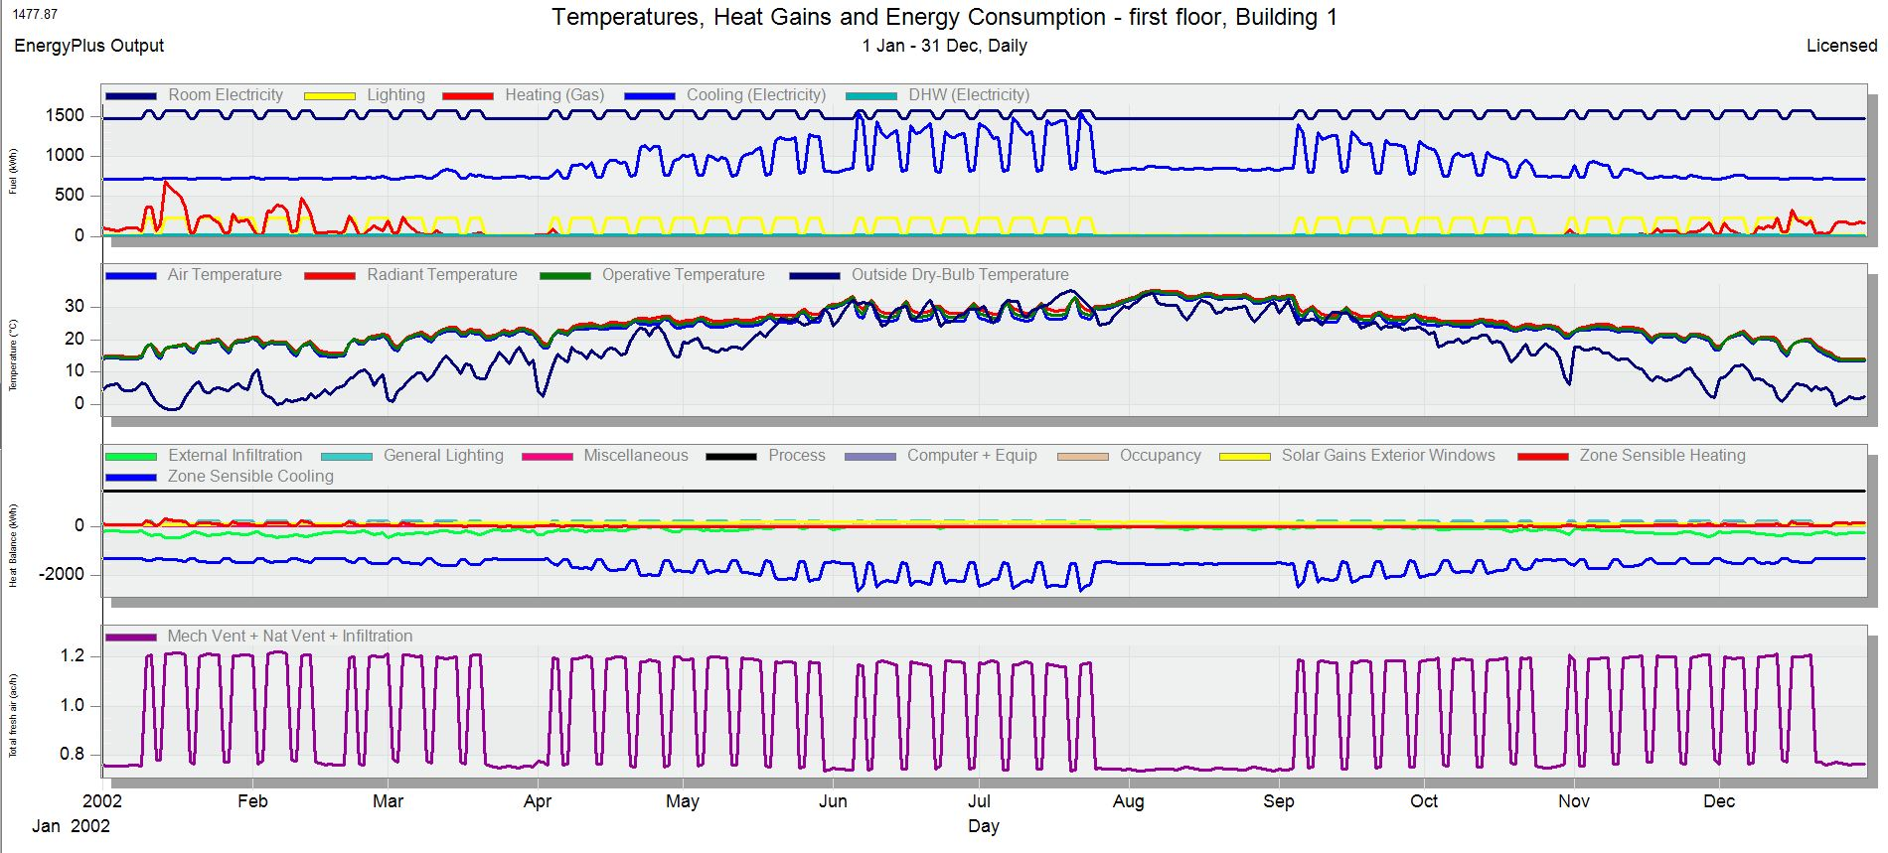

داده مورد استفاده شده:

|  |  |  |
| --- | --- | --- |
| **zone** | **zone type** | **sector** |
| **abdar khane** | standard | general |
| **abdar khane1** | standard | general |
| **elevator** | cavity | general |
| **elevator1** | cavity | general |
| **hall,voroodi,estrahat,kafishop** | standard | offices and workshop businesses |
| **hall,voroodi,estrahat,kafishop1** | standard | education(non-residential institution) |
| **otagh server** | srandard | others-miscellaneaous 24h activities |
| **pish khan amoozesh-edare danesh amookhtegan-edareh paziresh** | srandard | education(non-residential institution) |
| **pishkhan,edareh,emtehanat,amoozeshi** | srandard | education(non-residential institution) |
| **rah pelleh** | cavity | education(non-residential institution) |
| **rah pelleh 1** | cavity | education(non-residential institution) |
| **rahpelleh & khorooje ezterari** | cavity | education(non-residential institution) |
| **rah pelleh 2** | cavity | education(non-residential institution) |
| **tahsilate takmili** | srandard | universities and collegues |
| **tishoeei** | semi-exterior unconditioned | offices and workshop businesses |
| **tishoeei1** | semi-exterior unconditioned | offices and workshop businesses |
| **vorood va khrooje ezterari** | cavity | education(non-residential institution) |
| **voroodi asli** | srandard | general |
| **wall** | - | general |
| **wc malol** | semi-exterior unconditioned | general |
| **wc malol 1** | semi-exterior unconditioned | general |
| **wc men** | semi-exterior unconditioned | education(non-residential institution) |
| **wc women** | semi-exterior unconditioned | education(non-residential institution) |

|  |  |  |
| --- | --- | --- |
| **zone** | **template** | **computers** |
| **abdar khane** | ashrey-kitchenette | no |
| **abdar khane1** | ashrey-kitchenette | no |
| **elevator** | Misc.Spaces-electrical equipment room | no |
| **elevator1** | Misc.Spaces-electrical equipment room | no |
| **hall,voroodi,estrahat,kafishop** | generic office area | no |
| **hall,voroodi,estrahat,kafishop1** | hall/lecture theatre/ assembly area/ | no |
| **otagh server** | server room | yes |
| **pish khan amoozesh-edare danesh amookhtegan-edareh paziresh** | office and consulting area | yes |
| **pishkhan,edareh,emtehanat,amoozeshi** | office and consulting area | yes |
| **rah pelleh** | circulation area (corridors and stairwys) | no |
| **rah pelleh 1** | circulation area (corridors and stairwys) | no |
| **rahpelleh & khorooje ezterari** | circulation area (corridors and stairwys) | no |
| **rah pelleh 2** | circulation area (corridors and stairwys) | no |
| **tahsilate takmili** | residents common rooms | no |
| **tishoeei** | store room | no |
| **tishoeei1** | store room | no |
| **vorood va khrooje ezterari** | circulation area (corridors and stairwys) | no |
| **voroodi asli** | office buildings-lobby main entry | no |
| **wall** | unoccupied | no |
| **wc malol** | wc private | no |
| **wc malol 1** | wc private | no |
| **wc men** | toilet | no |
| **wc women** | toilet | no |

|  |  |  |  |
| --- | --- | --- | --- |
| **zone** | **activity** | **factor** | **office equipment** |
| **abdar khane** | cooking 1 | 1( men ) | no |
| **abdar khane1** | cooking 1 | 0.925( men ) | no |
| **elevator** | light | 0.86((1+0.85+0.75)/3) | no |
| **elevator1** | light | 0.86((1+0.85+0.75)/3) | no |
| **hall,voroodi,estrahat,kafishop** | light office work/standing/walking | 0.9 | yes |
| **hall,voroodi,estrahat,kafishop1** | standing/walking/light office work | 0.9 | yes |
| **otagh server** | heavy | 0.9 | yes |
| **pish khan amoozesh-edare danesh amookhtegan-edareh paziresh** | office work/standing/walking | 0.925 | yes |
| **pishkhan,edareh,emtehanat,amoozeshi** | standing/walking/light office work | 0.925 | yes |
| **rah pelleh** | standing/walking | 0.925 | no |
| **rah pelleh 1** | standing/walking | 0.925 | no |
| **rahpelleh & khorooje ezterari** | standing/walking | 0.925 | no |
| **rah pelleh 2** | standing/walking | 0.925 | no |
| **tahsilate takmili** | lighter office work | 0.925 | yes |
| **tishoeei** | standing/walking | 0.925 | no |
| **tishoeei1** | standing/walking | 0.925 | no |
| **vorood va khrooje ezterari** | standing/walking | 0.925 | no |
| **voroodi asli** | walking about | 0.925 | no |
| **wall** | - | - | no |
| **wc malol** | seated queit | 0.925 | no |
| **wc malol 1** | seated queit | 0.925 | no |
| **wc men** | standing/walking | 1 | no |
| **wc women** | standing/walking | 0.85 | no |